**DEVELOP A REACT URL SHORTNER WEB APP**

**Aim:** The **URL Shortener** is a client-side web application built using **React** that allows users to:

* Convert long URLs into short, shareable links
* Set custom shortcodes for personalized URLs
* Track click analytics (total clicks, last accessed time)
* Set expiration times for shortened URLs

**Technical Implementation**

* **Frontend**: React (via CDN)
* **State Management**: React Hooks
* **Storage**: localStorage
* **Styling**: Plain CSS .

### **Key Components :**

#### **State Management**

const [urls, setUrls] = React.useState([]);

const [inputUrl, setInputUrl] = React.useState('');

const [customCode, setCustomCode] = React.useState('');

const [validity, setValidity] = React.useState(30);

const [error, setError] = React.useState('');

#### **URL Shortening Logic**

const shortenUrl = () => {

if (!inputUrl) return setError("Please enter a URL!");

const shortCode = customCode || Math.random().toString(36).substring(2, 8);

const newUrl = {

original: inputUrl,

short: `${window.location.href.split('#')[0]}#${shortCode}`

clicks: 0,

createdAt: Date.now(),

expiresAt: Date.now() + validity * 60000,

clickHistory: []

};

setUrls([...urls, newUrl]);

};

#### **Redirection & Click Tracking**

React.useEffect(() => {

const hash = window.location.hash.substring(1);

if (hash) {

const urlObj = urls.find(u => u.short.endsWith(`#${hash}`));

if (urlObj) {

const updatedUrls = urls.map(u => ({

...u,

clicks: u.clicks + (u.short.endsWith(`#${hash}`) ? 1 : 0),

clickHistory: [...u.clickHistory, { timestamp: Date.now() }]

}));

setUrls(updatedUrls);

window.location.href = urlObj.original; // Redirect

}

}

}, [urls]);

**OUTPUTS:** 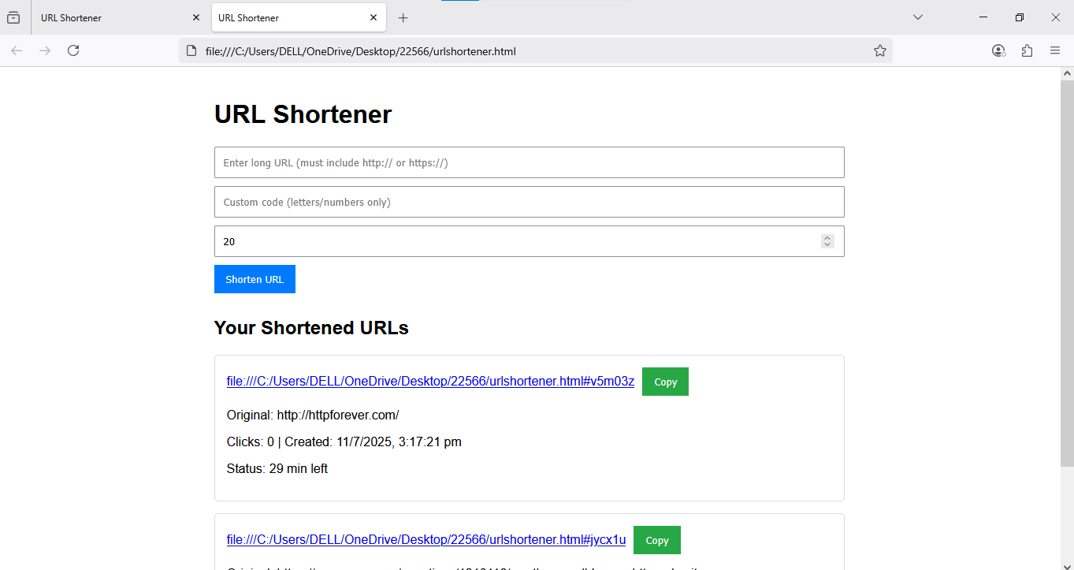

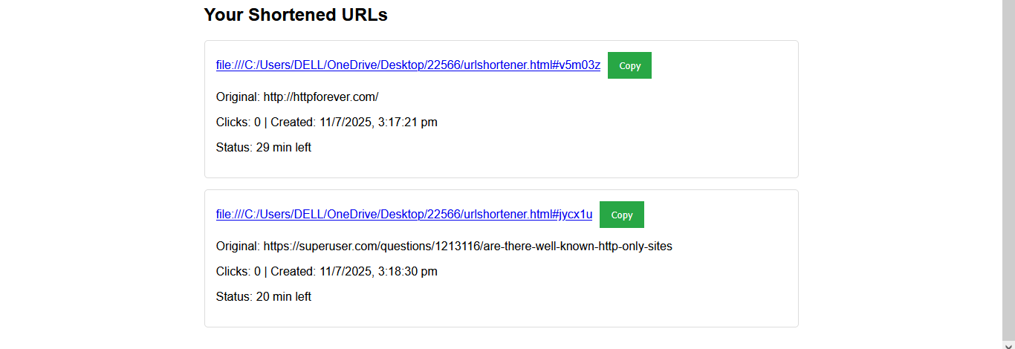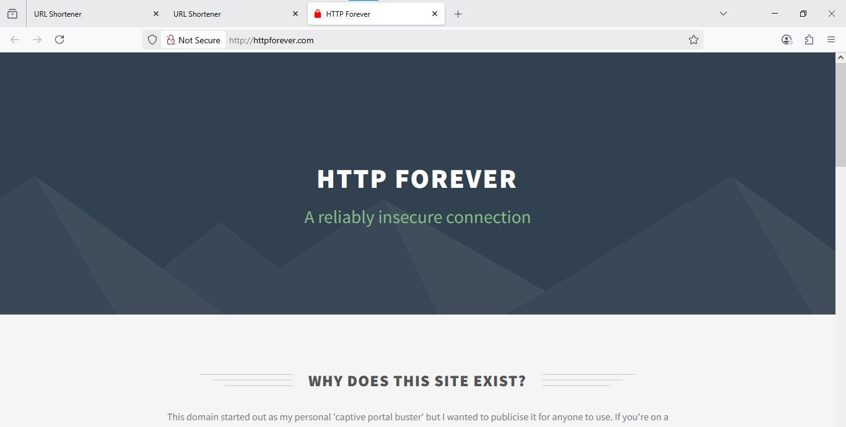

**CONCLUSION:** The **URL Shortener** application successfully delivers a **fast, lightweight, and user-friendly** solution for converting long URLs into short, shareable links—all while operating entirely on the client side. By leveraging **React** for dynamic rendering, **localStorage** for data persistence, and **modern JavaScript** for logic, this tool provides essential URL management features without requiring a backend server.